2022-2023
Dr. Haider Mahdi Lieth 2ND YEAR SEMESTER :1ST CODE: ME214
Chapter Three : plain carbon steel
Ferrous materials :-
Those with iron as prime constituent (except for high alloy steel) , Important as engineering construction material (especially steel Fe-C) is because: -
1. low cost 2. Easier to be produced
3. Good strength toughness and ductility
4. Can be alloyed and heat treated to get desired mechanical properties
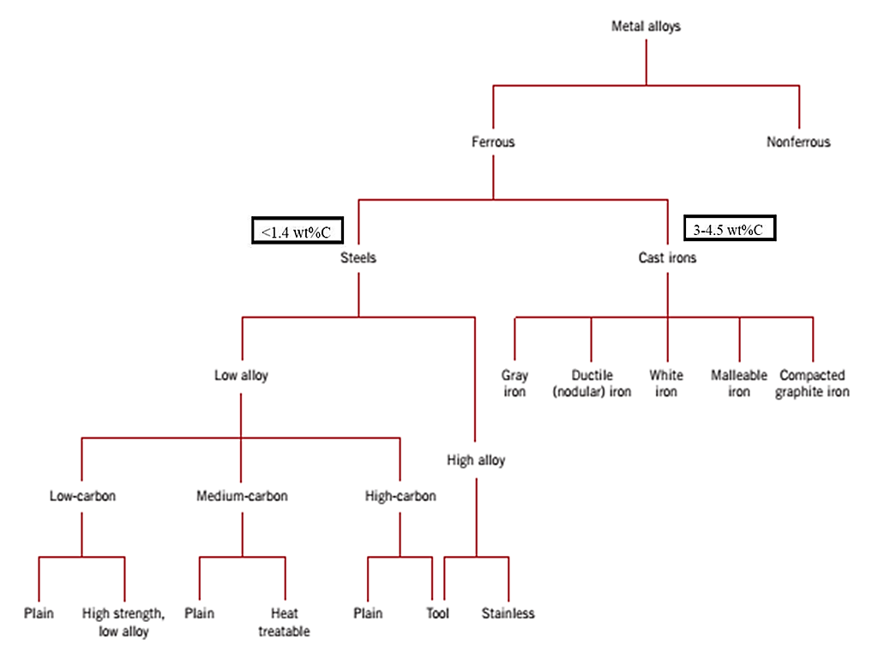
Alloying is combining or mixing other material like carbon or other metals to iron ,Heat treatment is a process of heating and cooling a metal to achieve specific microstructure which in turns display specific mechanical properties (e.g. Quenching austenite gives martensite witch be treated to martensite which is can heat (tempered) produced tempered more ductile.

Nomenclature of Ferrous Alloys
Nomenclature AISI (American Iron and Steel Institute) & SAE (Society of Automotive Engineers)
The AISI maintained a numbering system for wrought stainless steel in which the three digits indicate the various compositions. The 200 and 300 series are generally austenitic stainless steels, whereas the 400 series are either ferritic or martensitic. Some of the grades have a one-letter or two-letter suffix that indicates a particular modification of the composition.
The unified numbering system (UNS) is an alloy designation system widely accepted in North America. Each UNS number relates to a specific metal or alloy and defines its specific chemical composition, or in some cases a specific mechanical or physical property. A UNS number alone does not constitute a full material specification because it establishes no requirements for material properties, heat treatment, form, or quality.
10xx Plain Carbon Steels
11xx Plain Carbon Steels (desulfurized for machinability)
15xx Mn (10 ~ 20%)
40xx Mo (0.20 ~ 0.30%)
43xx Ni (1.65 - 2.00%), Cr (0.4 - 0.90%), Mo (0.2 - 0.3%)
44xx Mo (0.5%)
Where xx is wt% C x 100
Example: 1060 steel – plain carbon steel with 0.60 wt% C
Stainless Steel -- >11% Cr – AISI number e.g. 409
The Iron-Carbon Phase Diagram :
- A portion of the iron–carbon phase diagram is presented in Figure 3. 2 Pure iron, upon heating, experiences two changes in crystal structure before it melts. At room temperature the stable form, called ferrite, or (α ) iron, has a BCC crystal structure. Ferrite experiences a polymorphic transformation to FCC austenite, or (γ) iron, at (910^{O}C). This austenite persists to (1390^{O}C ), at which temperature the FCC austenite reverts back to a BCC phase known as δ ferrite, which finally melts at (1535 ^{O}C ). All these changes are apparent along the left vertical axis of the phase diagram.
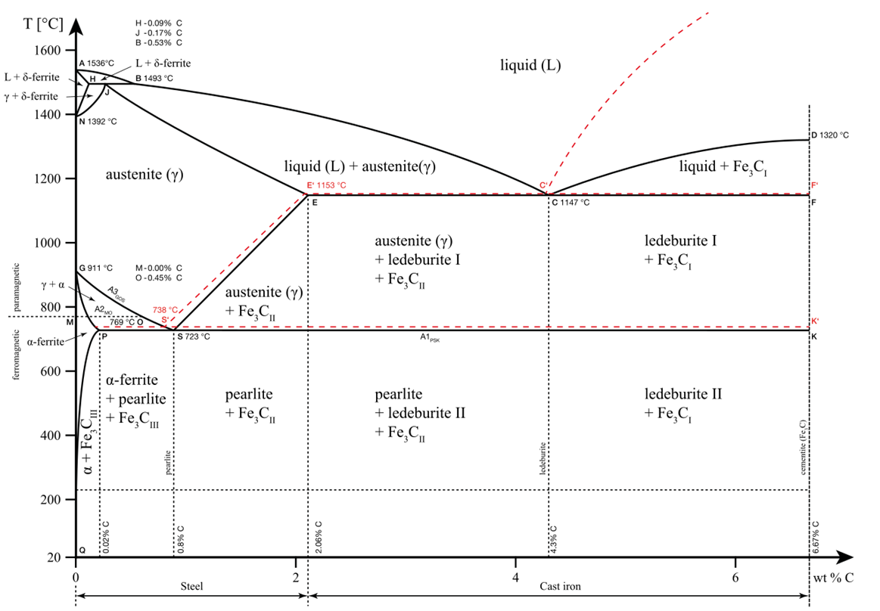
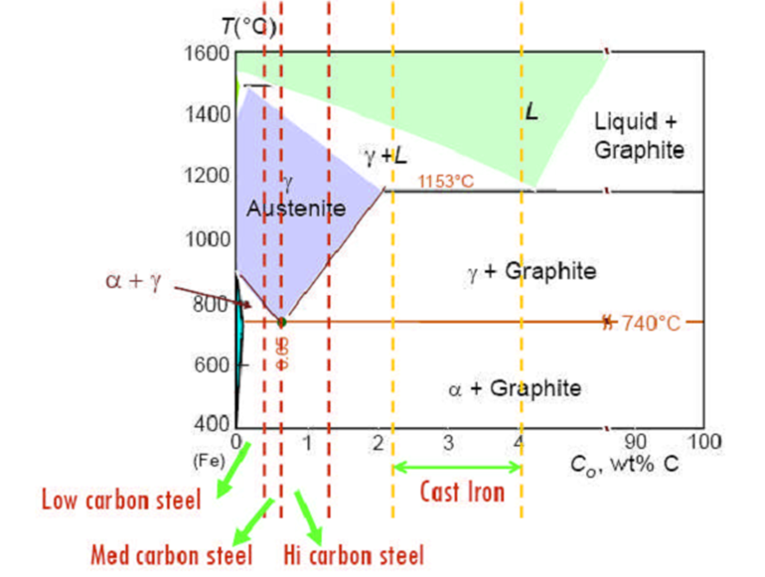
Figure 3-2 :- The iron–iron carbide phase diagram

- The composition axis in Figure 3.2 extends only to 6.7 wt % C; at this concentration the intermediate compound iron carbide, or cementite (Fe₃C), is formed, which is represented by a vertical line on the phase diagram.
- Thus, the iron–carbon system may be divided into two parts: an iron-rich portion, as in Figure 3.2 and the other (not shown) for compositions between 6.7 and 100 wt% C (pure graphite). In practice, all steels and cast irons have carbon contents less than 6.7 wt% C; therefore, we consider only the iron–iron carbide system.
- Figure 3.2 would be more appropriately labeled the Fe–Fe₃C phase diagram, since Fe₃C is now considered to be a component. Convention and convenience dictate that composition still be expressed in “wt% C” rather than “wt% Fe₃C”; 6.7 wt% C corresponds to 100 wt% Fe₃C.
- Carbon is an interstitial impurity in iron and forms a solid solution with each of α and δ ferrites, and also with γ austenite, as indicated by the and single phase fields in Figure 3.2. In the BCC α ferrite, only small concentrations of carbon are soluble; the maximum solubility is 0.03 wt% at ( 723^{O}C).
- The limited solubility is explained by the shape and size of the BCC interstitial positions, which make it difficult to accommodate the carbon atoms. Even though present in relatively low concentrations, carbon significantly influences the mechanical properties of ferrite.
- This particular iron–carbon phase is relatively soft, may be made magnetic at temperatures below (769^{O}C ), and has a density of 7.88 g/cm³. Figure 3.3a is a photomicrograph of a ferrite.
- The austenite, or γ phase of iron, when alloyed with carbon alone, is not stable below(723^{O}C ), as indicated in Figure 3.2The maximum solubility of carbon in austenite,1.7 wt%, occurs at(1130^{O}C ). This solubility is approximately 100 times greater than the maximum for BCC ferrite, since the FCC interstitial positions are larger and, therefore, the strains imposed on the surrounding iron atoms are much lower.
- As the discussions that follow demonstrate, phase transformations involving austenite are very important in the heat treating of steels. In passing, it should be mentioned that austenite is nonmagnetic. Figure3.3b shows a photomicrograph of this austenite phase.
- The δ ferrite is virtually the same as ferrite, except for the range of temperatures over which each exists. Since the δ ferrite is stable only at relatively high temperatures, it is of no technological importance and is not discussed further.
- Cementite (Fe₃C) forms when the solubility limit of carbon in α ferrite is exceeded below ) (for compositions within the α + Fe₃C phase region). As indicated in Figure 3.2, Fe₃C will also coexist with the γ phase between 723^{O}C and 1130^{O}C. Mechanically, cementite is very hard and brittle; the strength of some steels is greatly enhanced by its presence. Strictly speaking, cementite is only metastable; that is, it will remain as a compound indefinitely at room temperature.
- The two-phase regions are labeled in Figure 3.2. It may be noted that one eutectic exists for the iron–iron carbide system, at 4.3 wt% C and 1130^{O}C for this eutectic reaction,

L(4.3wt%C) ↔ γ (1.7wt%C) +Fe3C (6.67wt%C) ------- (3-1)

The liquid solidifies to form austenite and cementite phases. Of course, subsequent cooling to room temperature will promote additional phase changes. It may be noted that a eutectoid invariant point exists at a composition of 0.83 wt% C and a temperature of 723^{O}C This eutectoid reaction may be represented by
γ (0.83wt%C)↔α (0.03wt%C) +Fe3C (6.67wt%C) ------- (3-2)

or, upon cooling, the solid phase γ is transformed into α iron and cementite The eutectoid phase changes described by Equation 3-2 are very important, being fundamental to the heat treatment of steels, in. Ferrous alloys are those in which iron is the prime component, but carbon as well as other alloying elements may be present. In the classification scheme of ferrous alloys based on carbon content, there are three types: iron, steel, and cast iron. Commercially pure iron contains less than 0.008 wt% C and, from the phase diagram, is composed almost exclusively of the ferrite phase at room temperature .The iron–carbon alloys that contain between 0.008 and 1.7 wt% C are classified as steels. In most steels the microstructure consists of both α and Fe₃C phases. Upon cooling to room temperature, an alloy within this composition range must pass through at least a portion of the -phase field; distinctive microstructures are subsequently produced, as discussed below. Although a steel alloy may contain as much as 1.7 wt% C, in practice, carbon concentrations rarely exceed 1.0 wt%. Cast irons are classified as ferrous alloys that contain between 1.7 wt% C and 6.67 wt% C. However, commercial cast irons normally contain less than 4.5 wt% C. These alloys are discussed later.
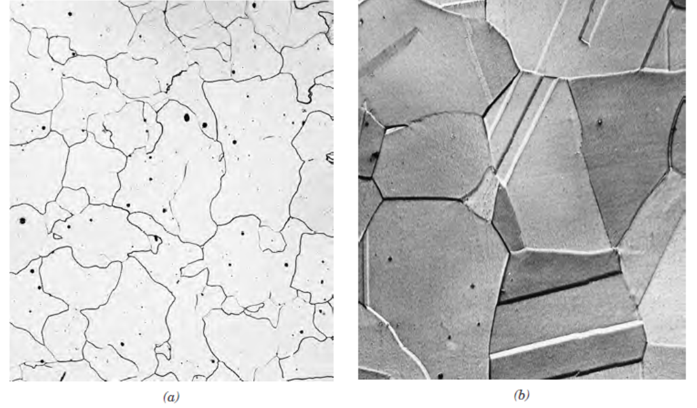
Figure 3.3 Photomicrographs of(a) ferrite (90 X) and (b) austenite (325 X)

Six basic solid phases
- δ-phase: solid solution of C in bcc Fe at high T.
- γ-Fe (Austenite):-solid solution of C in FCC iron, formed by solidification from liquid, large grains and straight grain boundaries, stable at high temperatures, high solubility for C, high ductility .
- α-Fe (ferrite): A solid solution of C in BCC iron, formed from austenite through solid phase transformation, small grains and irregular grain boundaries, stable at room temperature, ductile and soft, not so strong.
- Pearlite (P): composite structure of laminar ferrite and cementite, formed as a product of eutectoid transformation from Austenite, good combined strength and toughness, ideal for structural applications.
- Graphite (G): pure C; stable.
- Iron carbide (Fe₃C ) this is also called cementite , it is white , very hard and brittle . the more cementite the steel contains , the harder and more brittle it becomes .
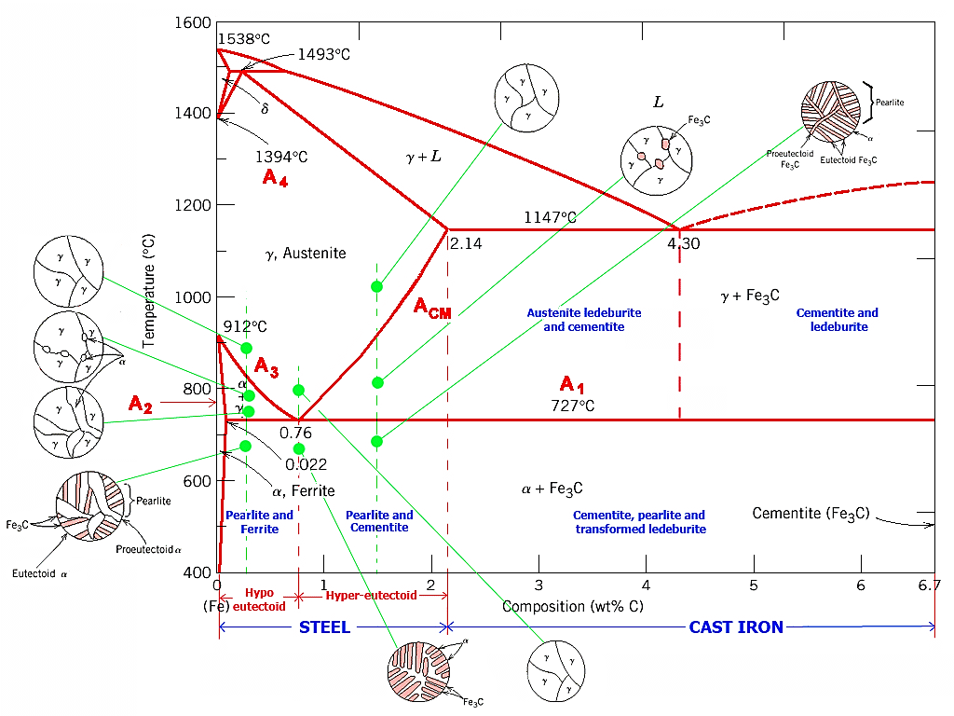

Properties and application of plain steel carbon
a)- Low carbon or mild steel (0.15% to 0.25% C):
Properties:-
(i) It is soft, malleable and offers good ductility.
(ii) Tough but have low wear resistance.
(iii) Easily forged and welded.
Applications:- It is used for making screws, nuts, bolts, rivets, thin canes, chains, wires, Automobile frames.
b) -Medium carbon steel:
It contains 0.25 to 0.6% of carbon and is stronger than mild steel.
Properties: It harder but less ductile than mild steel.
Application:- Used for making stronger screws, nuts, bolts, rivets, shafts, connecting rods,gears, crankshafts, axles, crank hooks etc.
c) High carbon steel:
Properties:
(i) Mechanical properties can be easily changed by various heat treatments processes.
(ii) Highest tensile strength and hardness in plain carbon steels.
(iii) Lowest ductility and machinability in plain carbon steels.
Applications: -
Due to good tensile strength and hardness, high carbon steels find extensive
application in hand tools, cutting tools, drills, milling cutters, wood working
tools, chisels, shear blades, spring wires, etc.
note:- Dead mild steel (upto 0.15% C):- It is used for making high ductility wires, thin sheets, rods, tubes etc.
Limitations of plain carbon steel.
Like everything, the plain carbon steels do have some appreciable properties but also consists of some limitations. These are:
1. There cannot be strengthening beyond about 100000 psi without significant loss in toughness (impact resistance) and ductility.
2. Large sections cannot be made with a martensite structure throughout, and thus are not deep hardenable.
3. Rapid quench rates are necessary for full hardening in medium-carbon leads to shape distortion and cracking of heat-treated steels.
4. Plain-carbon steels have poor impact resistance at low temperatures.
5. Plain-carbon steels have poor corrosion resistance for engineering problems.
6. Plain-carbon steel oxidises readily at elevated temperatures.

